6.2 Analysis of Finite Word Length Effects in Digital Signal Representation Using
Truncation and Rounding Techniques in MATLAB

CODING:
clc;
clear;
close all;

%% Generate Signal
n = 0:79;
x = sin(2*pi*n/40);

%% Quantization
q = 8;

% Truncation quantization
xt = floor(x*q)/q;

% Rounding quantization
xr = round(x*q)/q;

%% Quantization Error
et = x - xt; % Truncation error
er = x - xr; % Rounding error

%% Figure 1: Original vs Quantized
figure;
plot(n, x, 'b', 'LineWidth', 1.5);
hold on;
plot(n, xr, 'r', 'LineWidth', 1.5);
grid on;

title('Original vs Quantized');
xlabel('Sample Number');
ylabel('Amplitude');
legend('Original', 'Quantized');
hold off;

%% Figure 2: Truncation vs Rounding
figure;
plot(n, x, 'b', 'LineWidth', 1.5);
hold on;
plot(n, xt, 'r', 'LineWidth', 1.5);
plot(n, xr, 'g', 'LineWidth', 1.5);
grid on;

title('Truncation vs Rounding');
xlabel('Sample Number');
ylabel('Amplitude');
legend('Original', 'Truncated', 'Rounded');
hold off;

%% Figure 3: Quantization Error
figure;
stem(n, et, 'r', 'filled');
hold on;
stem(n, er, 'g', 'filled');
grid on;

title('Quantization Error');
xlabel('Sample Number');
ylabel('Error');
legend('Truncation', 'Rounding');
hold off;

%% Figure 4: MSE Comparison
mse_truncation = mean(et.^2);
mse_rounding = mean(er.^2);

figure;
bar([mse_truncation, mse_rounding]);

set(gca, 'XTick', 1:2);
set(gca, 'XTickLabel', {'Truncation', 'Rounding'});

grid on;
title('MSE Comparison');
ylabel('MSE');
xlabel('Quantization Method');

%% Display MSE Values
fprintf('MSE for Truncation = %.6f\n', mse_truncation);
fprintf('MSE for Rounding = %.6f\n', mse_rounding);

OUTPUT:
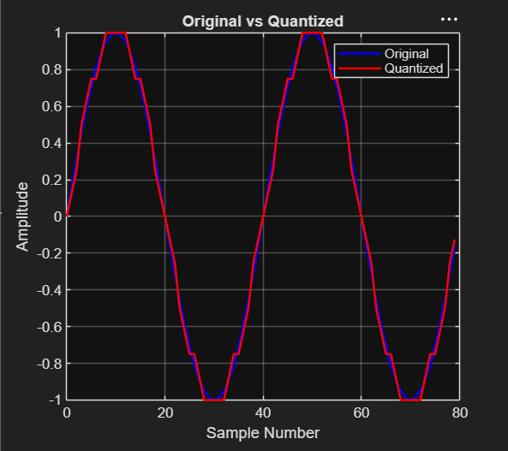
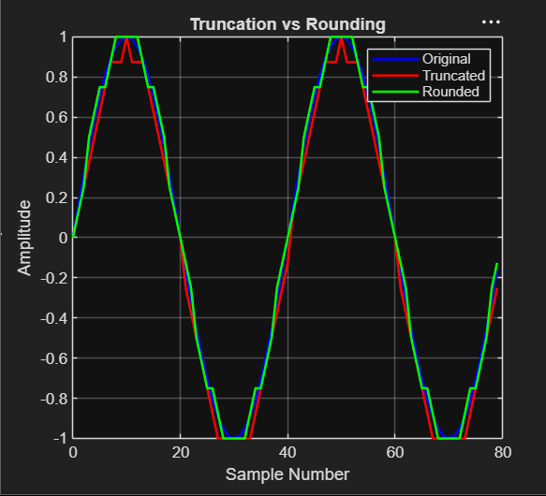
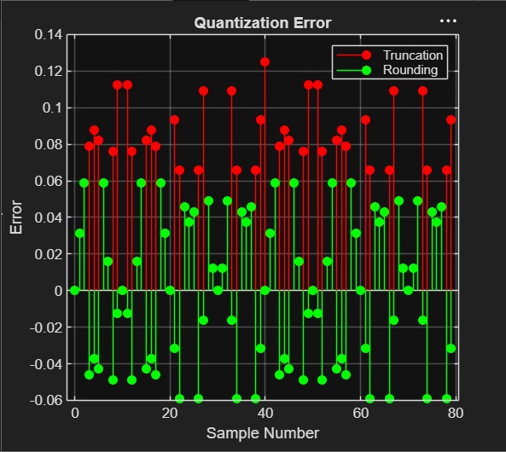
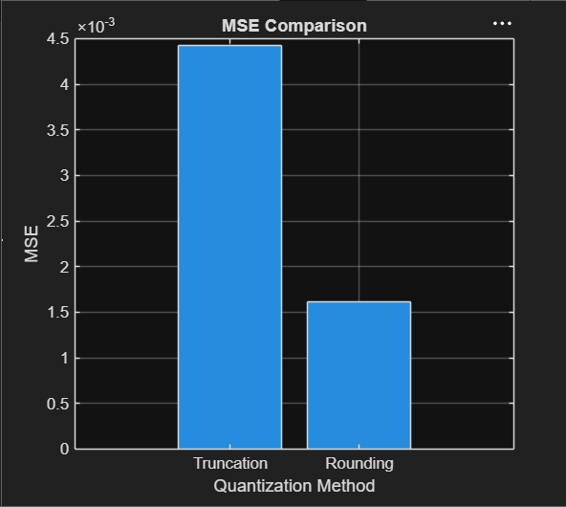

RESULT:
MSE for Truncation = 0.004426
MSE for Rounding = 0.001610
>>

